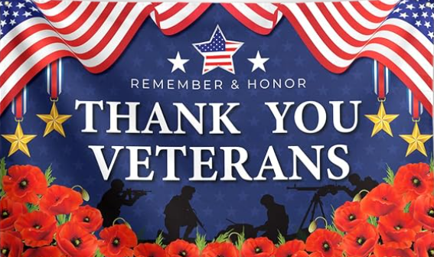
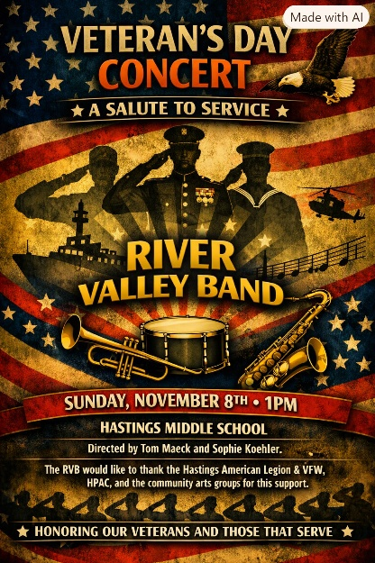
The public is welcome to celebrate Veterans Day 2026 on Sunday Nov 8th with a FREE concert at the Hastings Middle School Auditorium. The River Valley Band will perform at this annual event to Honor our local Veterans and First Responders.
CONCERT: Sunday Nov 8th 1pm – 215pm FREE!

VETERANS DAY DINNER – (Open to Public)
Hastings Public House (Golf Course)
Social Hour: 4pm-5pm - Dinner 5pm-6pm - Program 6pm-7pm
$20.00 per ticket call Jim Murtaugh 651-442-0348

